Recipe Book Project Report

1. Project Title
Recipe Book Web Application

2. Project Objective
The objective of this project is to create an interactive web application that allows users to browse, search, and view various recipes. The project is developed using HTML, CSS, and JavaScript, providing a dynamic and user-friendly interface for users to explore recipes easily.

3. Supported Technologies
- HTML: Used for structuring the content of the web pages.
- CSS: Used for styling the web pages and making the interface visually appealing.
- JavaScript: Used to add interactivity to the web application, such as filtering recipes, search functionality, and dynamic content updates.

4. Features
- Recipe Display: All recipes are displayed as cards with the recipe name, image, and description.
- Search Functionality: Users can search for recipes by name or ingredient.
- Filter Options: Recipes can be filtered based on categories like Breakfast, Lunch, Dinner, and Dessert.
- Responsive Design: The web application is fully responsive and works on both desktop and mobile devices.
- Dynamic Updates: Recipes are dynamically displayed using JavaScript without reloading the page.

5. Project Modules

5.1 HTML Module
- Contains the structure of the web pages.
- Main elements include navigation bar, search input, recipe cards container, and footer.

5.2 CSS Module
- Provides styling for the navigation bar, recipe cards, buttons, and overall page layout.
- Uses Flexbox/Grid for responsive design.
- Adds animations and hover effects to enhance user experience.

5.3 JavaScript Module
- Handles dynamic operations like:
  - Filtering recipes by category.
  - Searching recipes by keyword.
  - Rendering recipe cards dynamically from an array of recipe objects.
  - Event handling for buttons and search input.

6. Sample Code Snippets

HTML Example
<div class="recipe-card">
<img src="recipe-image.jpg" alt="Recipe Image">
<h3>Recipe Name</h3>
<p>Short description of the recipe.</p>
</div>

CSS Example
.recipe-card {
border: 1px solid #ccc;
border-radius: 10px;
padding: 15px;
text-align: center;
transition: transform 0.3s;
}

.recipe-card:hover {
transform: scale(1.05);
}

JavaScript Example
const recipes = [
{ name: "Pasta", category: "Lunch", description: "Delicious Italian pasta." },
{ name: "Chocolate Cake", category: "Dessert", description: "Rich and moist cake." }
];

function displayRecipes(filteredRecipes = recipes) {
const recipeList = document.getElementById("recipe-list");
recipeList.innerHTML = "";
filteredRecipes.forEach(recipe => {
recipeList.innerHTML += `
<div class="recipe-card">
<h3>${recipe.name}</h3>
<p>${recipe.description}</p>
</div>
`;
});
}

7. Project Screenshots
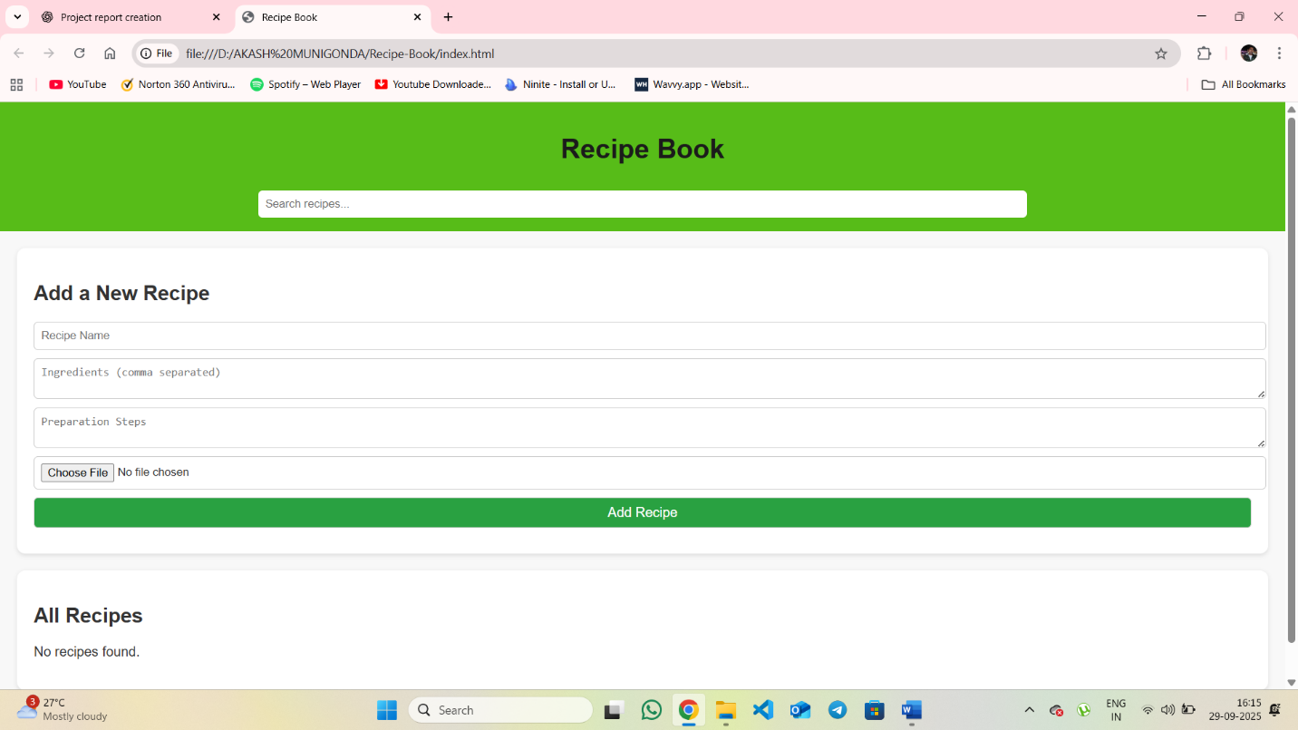
Home page with recipe list

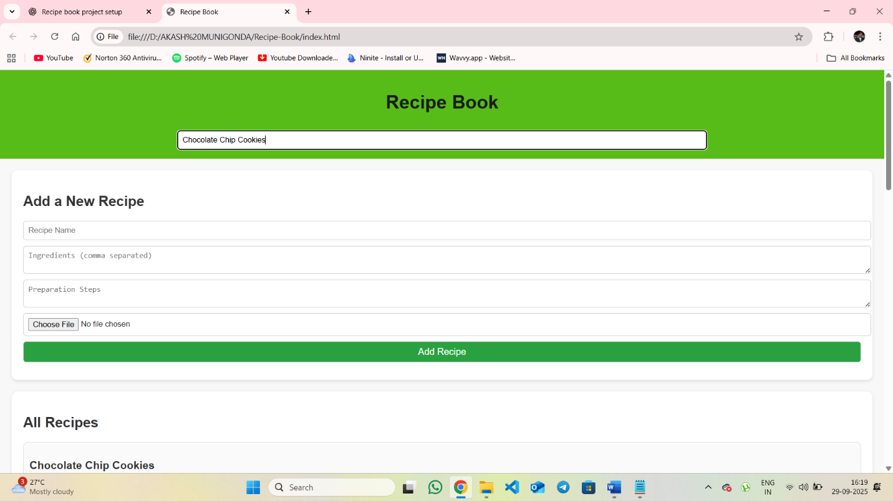
Search functionality in action
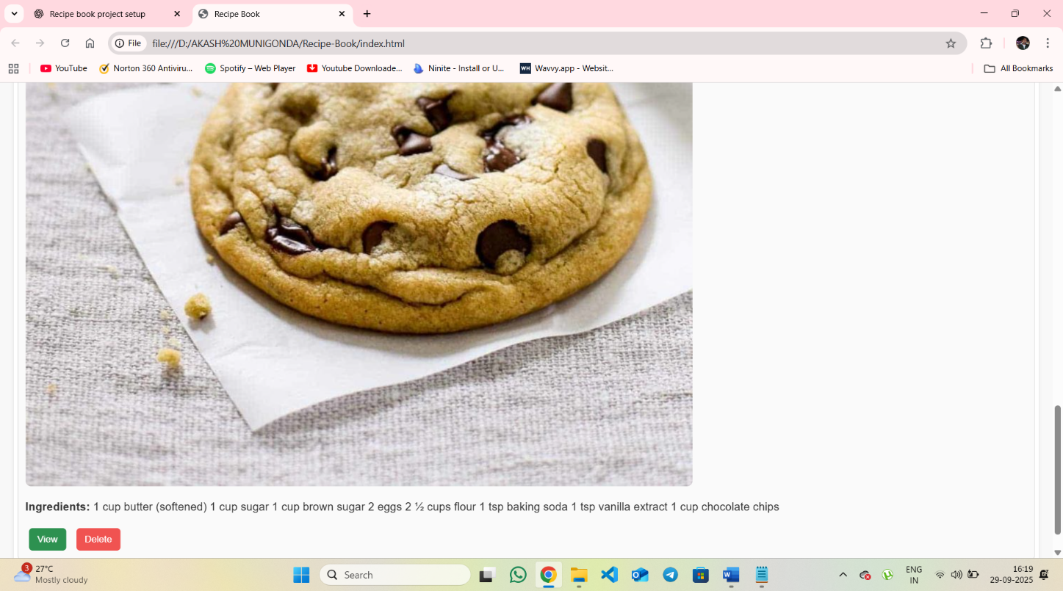
Responsive view

8. Challenges Faced
- Designing a responsive layout for different screen sizes.
- Implementing dynamic search and filter using JavaScript.
- Ensuring smooth user experience with animations and transitions.

9. Conclusion
The Recipe Book project demonstrates the use of HTML, CSS, and JavaScript to build an interactive web application. Users can easily browse, search, and filter recipes, making the application a useful and engaging tool for recipe management. This project enhances knowledge in front-end development and dynamic web design.

